**Software Requirement Specification**

**Hospital Management System**

**Introduction:**

Hospital Management System is a process of implementing all the activities of the hospital in a computerized automated way to fasten the performance.

This project is to maintain the patient details, lab reports and to calculate the bill of the patient. You can also manually edit any patient details and issue bill receipt to patient within few seconds.

**Purpose of this document:**

The document lists the following features that the Hospital Management System will provide :

* Admissions – Admitting patients, assigning patients to appropriate wards.
* Patient Care – Monitoring Patients while admitted and manage daily reports.
* Work Scheduling – Assigning nurses and doctors to patients.
* Report Management – Managing test reports
* Billing – Generating bills and keeping record of them.

**Feasibility Study:**

The overall scope of the feasibility study was to provide sufficient information to allow a decision to be made as to whether the hospital management system project should proceed and so, its relative priority in the context of the other existing hospital management system.

The feasibility study of this project had undergone through various steps which as describe as under:

1. Identify the origin of the information at different level.
2. Identify the expectation of user from computerized system.
3. Analyze the drawback of existing system.

**Functional Requirements:**

**R1** Registration

The HPMS should allow front desk staff to add new patients to the system.

**R1.1** Assign ID

Each patient will be given an ID which will be used throughout his stay

**R2** Consultation

**R2.1** General check-up

The assigned doctor does the general check-up. Accordingly asks the patient to have respective tests(blood,x-ray,etc) if required.

INPUT : Patent to be treated

Output : Patient is assigned ward if condition is critical

Output : If cond. not serious, give medicine and ask for regular check-ups.

**R3 Medical matter management**

**R3.1 Assign Doctor**

A doctor is assigned to the a given patient

**R3.2 Assign nurse**

A nurse is assigned to a given patient

**R3.3 Generate Report**

Daily report generated by the doctor has to be stored in the database

**R3.4 Record test reports and medicines given**

All the test reports and the medicines given to the patients should be recorded

**R4 Billing**

**R4.1 Billing for non-admitted patients**

One time procedure – Bills generated on a registered patient ID

**R4.2 Billing for admitted patients**

Bills generated regularly and added to the main bill.

Calculate outstanding dues regularly.

**DATA FLOW DIAGRAM :**

Assign doctor

Patient details

Doctor/Nurse

Front Desk Staff

Daily report,etc

Patient

id

Patient id

Updated bill

Test and Medicines list

Assign ID

Hospital Mgmt.

System

Billing and Patient records

Management

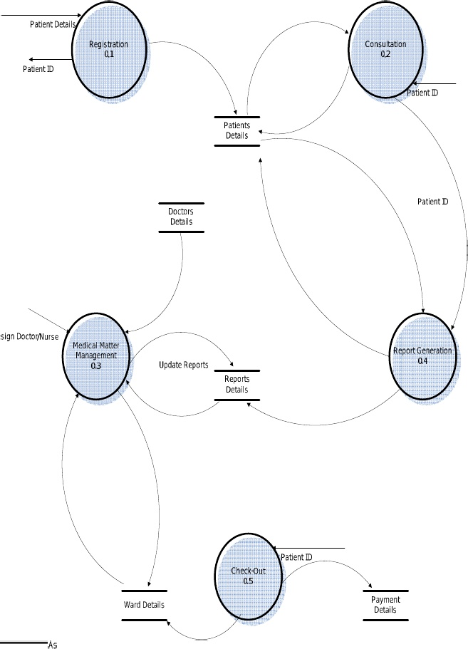

**3. SPECIFIC REQUIREMENTS**

It describes all the details that the software developer need to know for designing and developing the system. This is typically the largest and most important part of the document.

**3.1. External Interface Requirements:-**

**3.1.1. User Interface:-**

User interface is designed in a user friendly manner and the user, in another end he has to give the order, for that he will interface with keyboard and mouse.

**3.1.2. Hardware Interface:-**

1) OS – windows XP

2) Hard disk – 80 GB

3) RAM – 1 GB

4) Keyboard – Standard QWERTY keyboard for interface

5) Mouse – Standard mouse with 2 buttons

**3.1.3. Software Interface:-**

1) Front end – HTML/CSS, Javascript

2) Back end – SQL Server